Nam Phan

CS149

Assignment #2

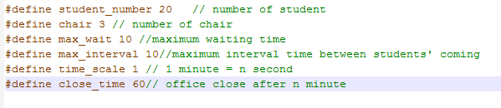

1) Define: these definitions can be changed to have different outputs, or testing

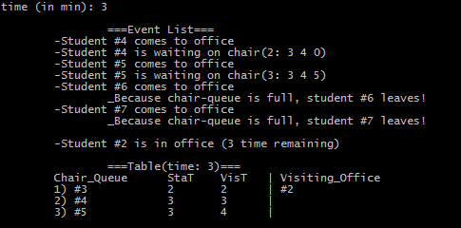

2)

-Current time

-List of event

-Table information (Student in chair, Student in Office)

3) Cygwin:

-I use Cygwin to run the code

-Locate the file assign2.c

-Run 2 commands:

$ gcc -o ass2 assign2.c  
 $ ./ass2

4)Extra Credit: it is included

5) Pthread:

-One pthread is used

-Use condition statements instead of mutex

6) Student:

-Generate as a struct

-Attribute: number, start_time, visit_time

7) Time:

-Use variable time_count as a clock

-Base on each second, the program simulates each event and report the result